The green oasis grows - the roots of the 1,500 trees donated by VITRONIC to the reforestation project “Waldliebe” are now all in the ground

Wiesbaden, July 2023
Taking responsibility for nature and future generations - this is one of the principles shared by the Taunusstein reforestation project "Waldliebe" and the globally active machine vision technology company VITRONIC, headquartered in Wiesbaden:
"When we heard about the "Waldliebe" project, we knew immediately: we have to support this! And I am very proud that all employees of VITRONIC, also from the other international group companies, are behind it. Because it contributes to making our world more sustainable and safer. For all of us," said Daniel Scholz-Stein, CEO VITRONIC Group. Already in the fall of 2022, VITRONIC donated 1,500 trees in the name of all global employees. With the support of HessenForst and the Rotary Club of Taunusstein, this considerable quantity of sessile oaks, pines and Douglas firs was now planted in the ground on an approximately 6-hectare forest area in Taunusstein-Hambach during the last Forest Love Planting Days in May and June 2023. Thus a new native mixed forest develops on fallow lying forest surface, which binds approx. 36 t CO2 per year. To the comparison: On each German citizen come at present approx. 11t CO2 per year - thus 3.3 humans would be CO2-neutral by this piece of forest.
Replacing the dead forest areas with new trees is the basic work - but for the people behind "Waldliebe" this was not enough, so they developed a "freestyle": A holistic and sustainable project to reforest the local forest with hei-mic tree species and to provide shelter, food and a home for the animal species settled there. A sophisticated water management system provides for the storage of rainwater and transports it up to an outdoor cistern for watering by means of a solar deep pump. Thus, even in dry periods, watering can be done with collected rainwater. Wooden fences protect the newly planted forest areas from game browsing to give the seedlings a chance to grow. The planting areas in the forest and the surrounding terrain are constantly being further developed: For example, on the last planting day in April 2023, bird nesting boxes were installed, seedlings that had decayed in the winter were replaced, and information signs and recreational areas for walkers were set up.
The Rotary Club of Taunusstein recently received the Sustainability Award 2023 for this well thought-out reforestation project "Waldliebe" ("Forest Love"), which has been made tangible.
A vision became reality - thanks to the many people who are involved with and in Waldliebe.
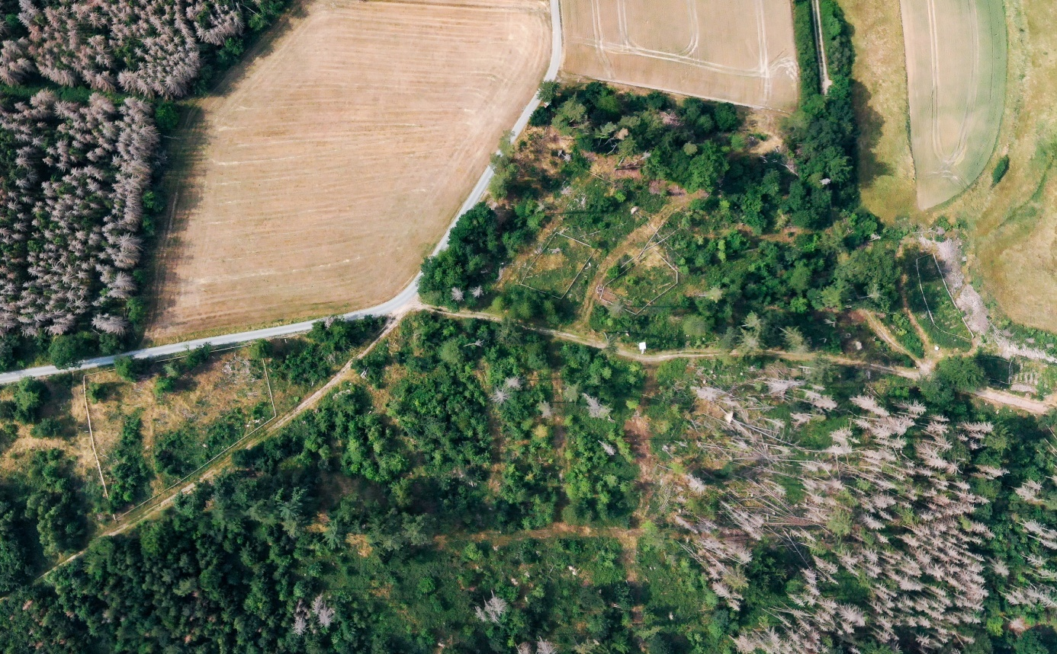
Picture: In the current drone images of Taunusstein-Hambach, the wood fencing makes it easy to see which forest areas have been replanted.

About VITRONIC
VITRONIC is the world's leading innovation driver for machine vision, enabling its customers to master the challenges of tomorrow.
The family-owned group of companies develops forward-looking solutions in the form of specialized products and software for image-based quality inspection, identification and process optimization, which find application in the growth sectors of automation and traffic engineering.
VITRONIC solutions make an important contribution to helping shape a safe and sustainable world. The existing limits of what is economically feasible are constantly being questioned in order to achieve the highest quality and productivity, for example in the production of automotive and pharmaceutical companies. Worldwide, Auto-ID solutions in logistics centers and at cargo airports, take over the reliable and efficient recording of shipments and thus ensure a transparent flow of goods.
In the transport sector, VITRONIC offers leading technology for increased safety on the roads, for optimizing traffic flow and for recording road usage.
Open and honest dealings with our customers form the foundation for jointly exploiting technological and process potential to the full. Joint success forms the basis of long-term cooperation with companies such as B. Braun, BMW, Daimler, DHL, UPS, Toll Collect, Fresenius and Sanofi as well as with public clients.
Since its foundation in 1984, VITRONIC has been growing continuously for almost 40 years. The current annual turnover (2022) is 208 million EURO and the company is currently represented on five continents in over 80 countries with approximately 1,300 employees.
Development and production of VITRONIC systems are located at the company headquarters in Wiesbaden. VITRONIC subsidiaries in North America, Europe, Asia and Australia, as well as a worldwide network of sales and service partners, provide local support to international customers.
Press contact:
xxx  Tel: +49 611 7152 xxx  xxx@vitronic.de  www.vitronic.de | VITRONIC Dr.-Ing. Stein  Bildverarbeitungssysteme GmbH  Hasengartenstr. 14  65189 Wiesbaden  Tel: +49 611 7152 0  Fax: +49 611 7152 133

